Groundcrew.AI Step 4.1

- Go to “Custom” topics in the Topics section and choose “+ Add a topic”
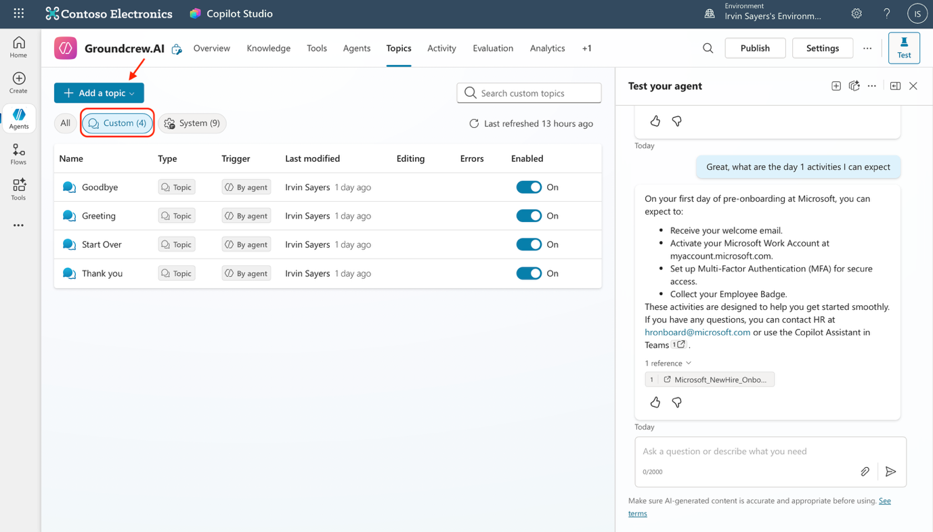

- Choose “ Start from blank” option. Then describe the purpose of this topic in the “describe section of the trigger node. You may use your own description or copy and paste this description
“This topic allows users to upload their headshots into the portal”

- Click on the “+” icon below the trigger node and add a question node. Input this on the message section “Great! I will help you upload your headshot into the portal! This will kick-off your badge creation process for you to have a smooth landing on Day”
Next, change the type to “File”
You may refer to the image below for better guidance
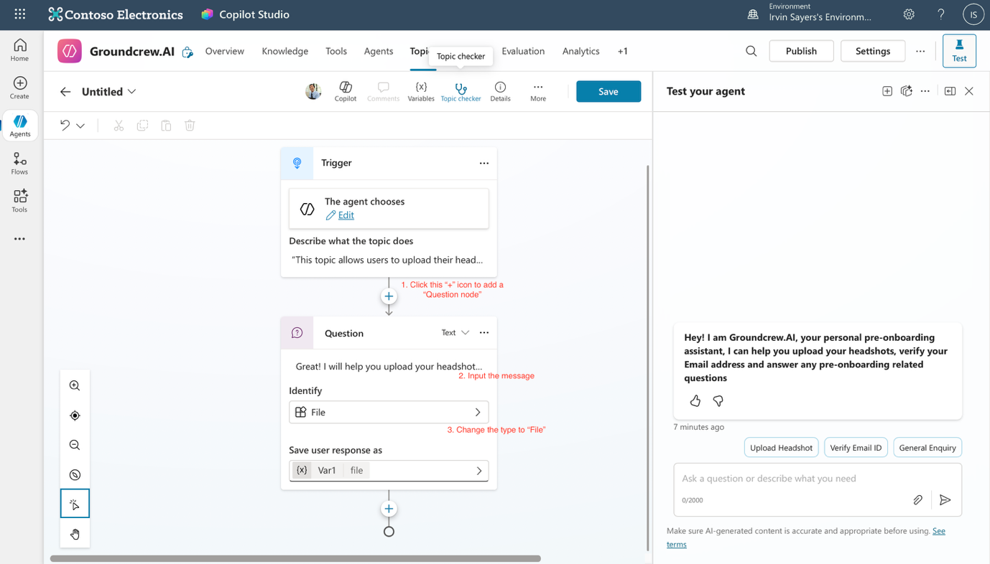

- Go to the section that says “Untitled” on the top left and change the name to “Upload Headshot” then click save

- Now we will be creating the flow to allow the agent to upload the image into Dataverse. On the side taskbar, click “Flows” and you will be redirected the the flow creation page

- In the flow creation page. Choose to “+New agent flow” and you will be brough to this page
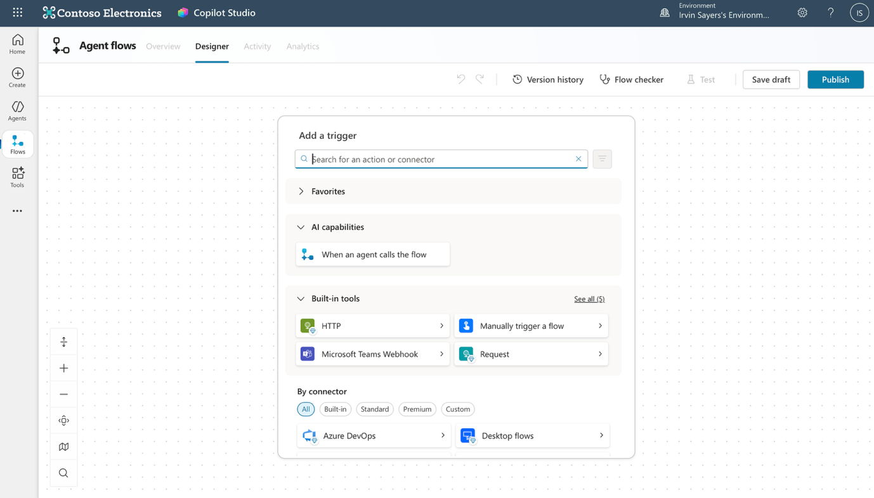

- Select “When an agent calls the flow”. Then click on “+ Add an input”. Choose “File” for input type and change the name from “File content” to “Headshot”.

- Next, click on the “+” icon below the trigger node and then choose “Microsoft Dataverse”
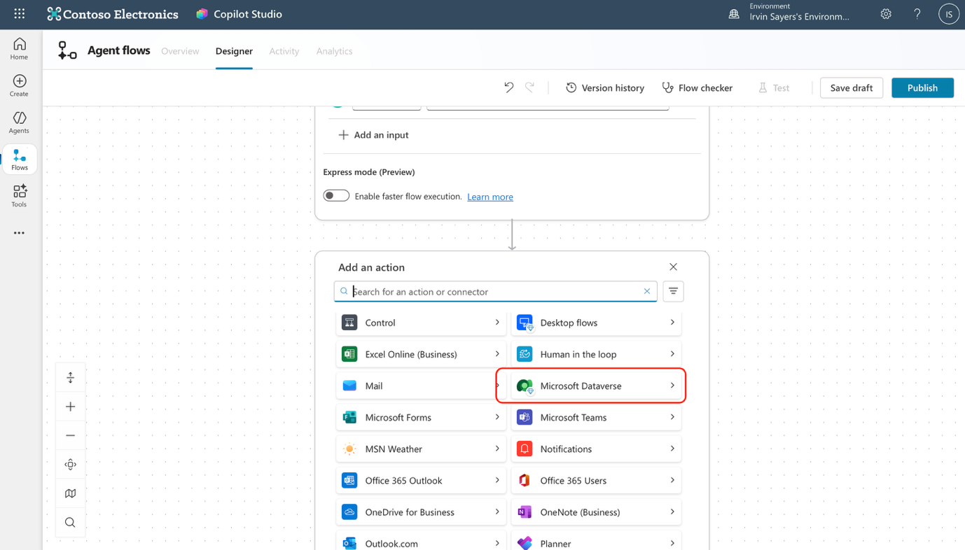

- After you have selected “Microsoft Dataverse” select “Upload a file or image to a selected environment” You will then see the node as shown below. You can give it any name. “Groundcrew” for example and click “sign in” to establish your connection
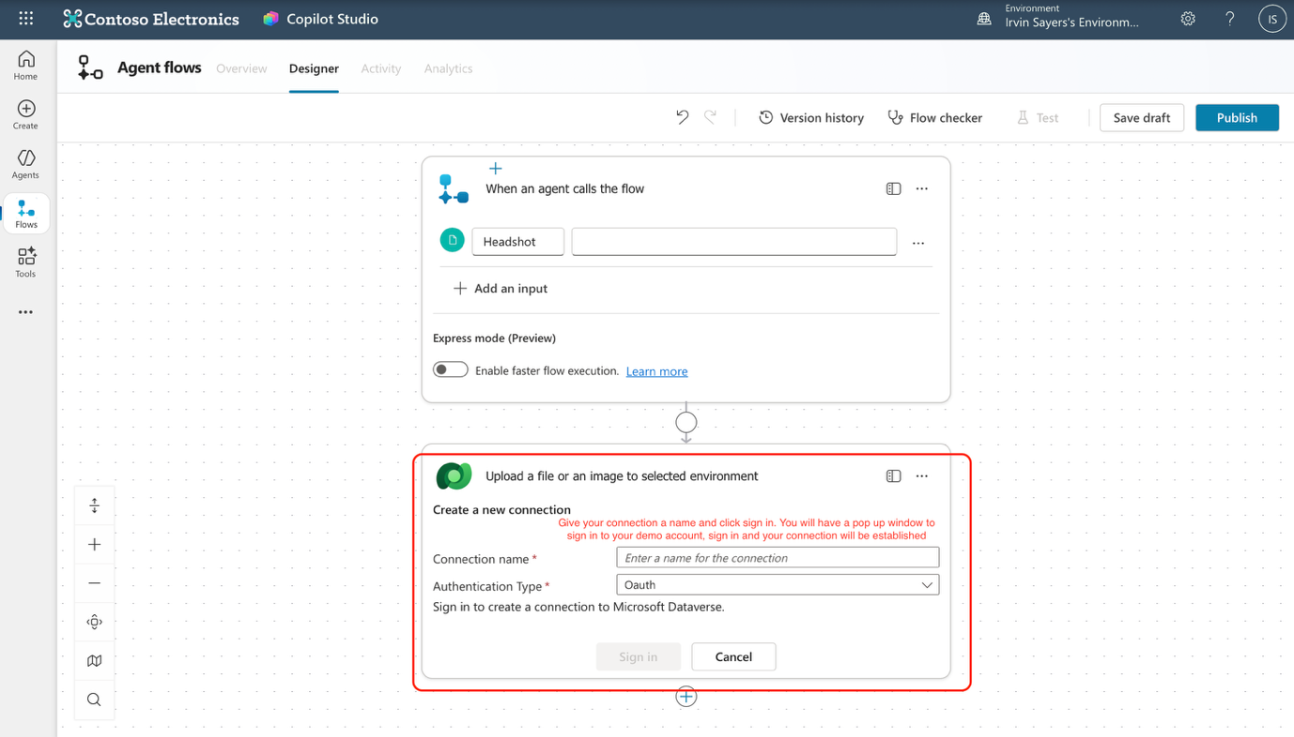

- You will then see this node. You may select the environment from a drop down function. Ensure to select the same environment as your agent and Dataverse table is in!
Content Name: Headshot
Table name: Search for the “Userverifications” table and select it
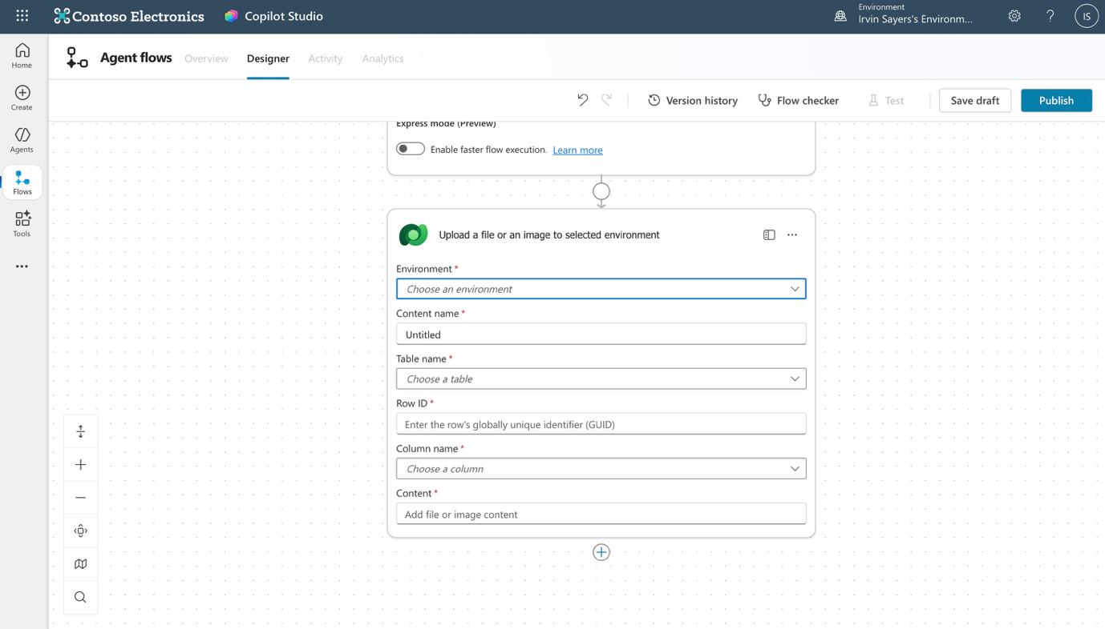

- We have to retrieve the RowID from the PowerApps Maker portal. So go to https://make.powerapps.com and view your Userverifications table. The GUID is the column named “Userverification”. This is a unique ID created for that row, You can copy it and paste it onto the “Row ID” in the connecter. Refer to below image.
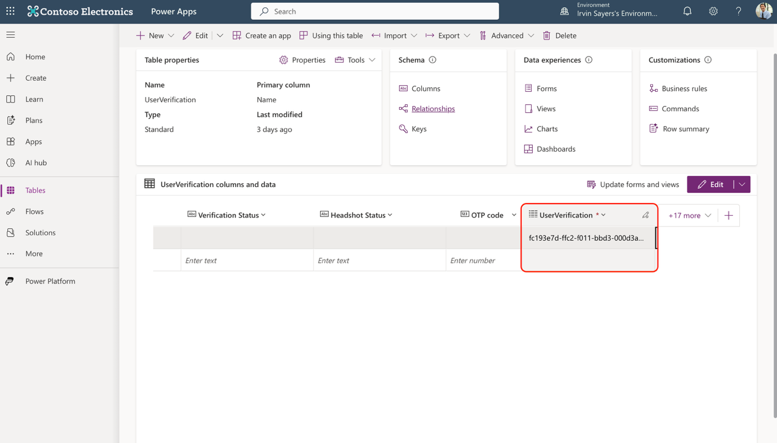

- Once you have entered the GUID, The column name “Headshot” should appear as a dropdown, select it. For the content, click on the “lightning” symbol and choose “Headshot contentBytes”

- Click on the “+” button below the dataverse node and choose “Respond to agent” and click “+ Add an output” and choose Text. Name it “Uploaded” and type in a message. You may use “ Your headshot has been successfully uploaded”

- Great work so far!, Your flow should look something like the image below. Once you have checked it, click “Publish”
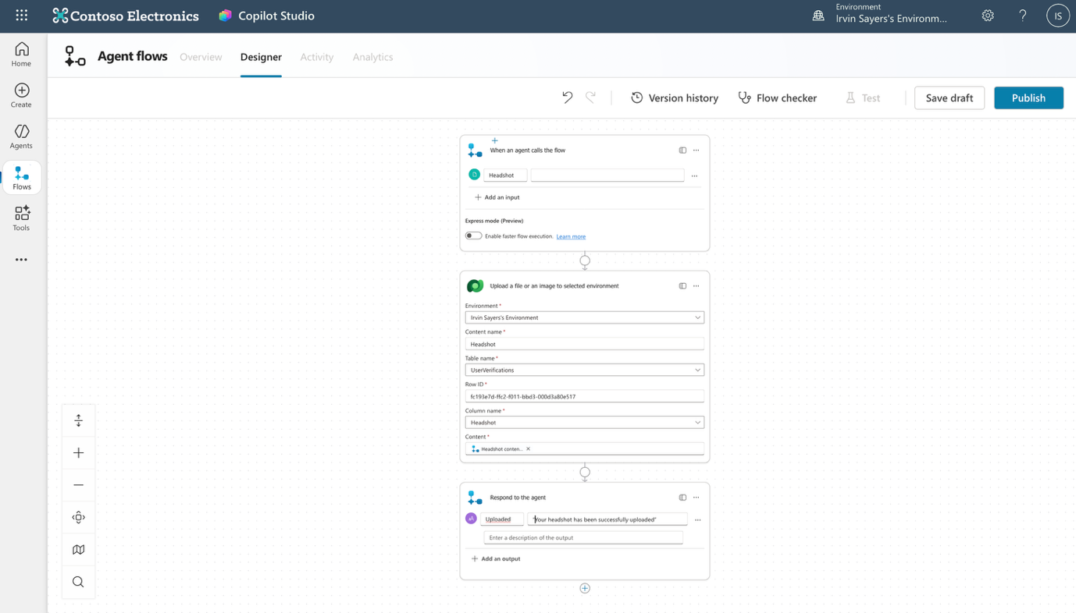

- Once your flow has been published, go to “Overview” tab and click “edit” and change the name to “Upload Headshot”
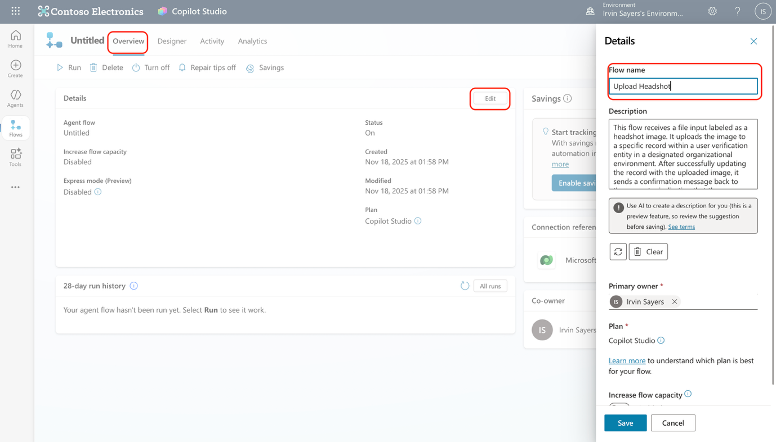

- Congratulation! You have finished building your first flow! Move on to the next step to integrate the flow into your topic!

